Sending Civilian Transcripts
Key rule: Order an official transcript directly through the transcript service. The Air University/ Education center will not use unofficial copies or transcripts sent by the student
Parchment  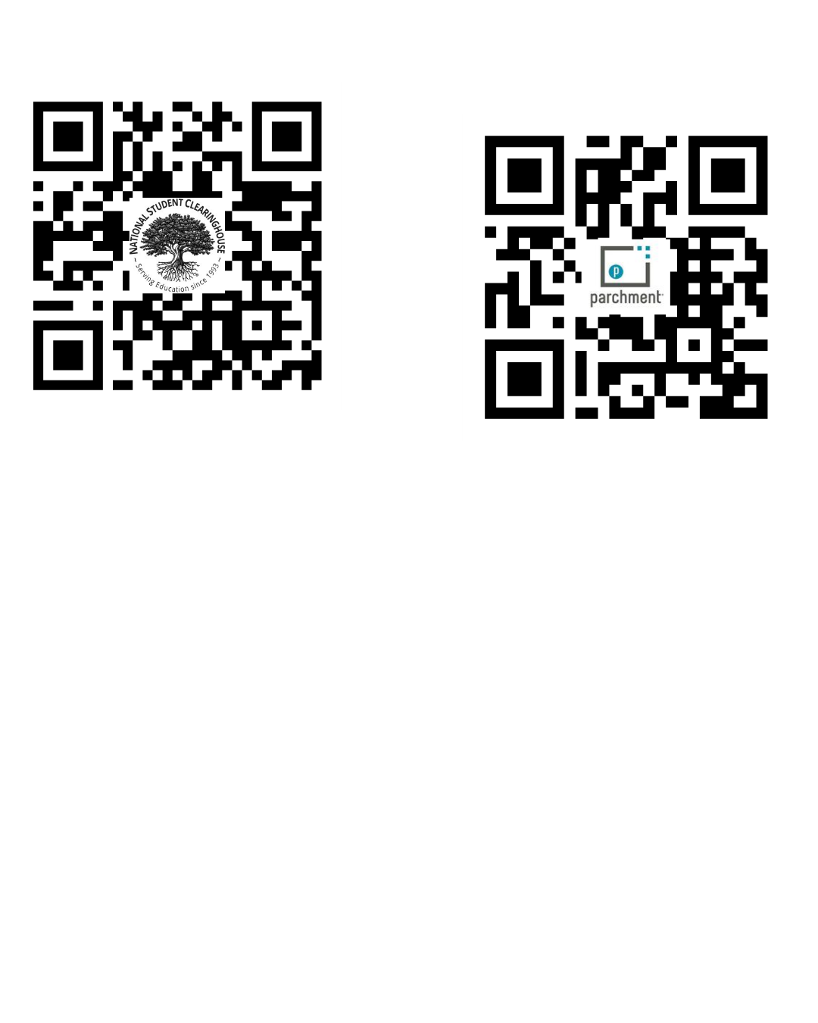  • Go directly to the Parchment website. The member does not have to start from the university page or log into the school student profile first, as long as Parchment can locate the school and order path.  • Create/sign in to Parchment, search for the civilian college, and request an official transcript.  • For the recipient, search/select/manual input:  CCAF  Air University  60 Schumacher Ave  Maxwell AFB  AL, 36112-6337  Baccalaureate and Masters  374 FSS/FSDE  Suite 244, Bldg 316  Yokota Air Base  Email: 374fss.fsde@us.af.mil  • Submit the order and save the confirmation number/email. | National Student Clearinghouse  • Use this option when the civilian school uses National Student Clearinghouse for official transcript orders.  • Order an official electronic transcript.  • When selecting the recipient, choose:  CCAF  Air University  60 Schumacher Ave  Maxwell AFB  AL, 36112-6337  Baccalaureate and Masters  374 FSS/FSDE  Suite 244, Bldg 316  Yokota Air Base  Email: 374fss.fsde@us.af.mil  • Save the order confirmation number/email.

Officers: All transcripts must be sent to Air University

After the Transcript Is Sent
✓ Keep the Parchment or National Student Clearinghouse confirmation email.
✓ Monitor the email for any Registrar follow-up.
✓ Do not send duplicate transcript requests unless directed.

